University of Cape Town
Department of Computer Science
Computer Science CSC3003S
Class Test 1, 2023

Answer all questions.
Approximate marks per question are shown in brackets.

Time: 40 minutes Marks: 35

Section 1. ASD1: Project Management [20 Marks]
Refer to the project brief below and answer the questions relating to the software development methods:
XYZ Inc is a non-governmental organization (NGO) that works with refugees and migrants to help them understand their rights and seek employment in South Africa. They have asked your company to develop a system that will allow their beneficiaries (the refugees and migrants) to browse and educational resources on a website, or to use a mobile app to access the content using the NGO’s internet, and then later to access the content from home without internet. The educational resources include short videos, text and graphic content. A mobile app should support browsing and search of the content. They want a proof of concept that can be tested with their beneficiaries and expect the content and the application features to change over time. They have a fixed budget for development over the next two years and have set a schedule for user testing and demonstrations once every two months.

Question 1 [10 Marks]
- You will take an agile approach for this project rather than waterfall. Use details from the brief above to justify your decision. [3]
In agile – scope is not fixed, while time and cost are. Scope is adjusted and prioritized so that the most important bits are completed first and additional features are only completed if time and budget are available.
+1 for capturing agile triangle (this may duplicate one of the points below) but for this point the student should note time/scope/cost together
Any two of the following (1 each) or other reasonable arguments for agile, should cite the details as noted in the brief:
- COST: “fixed budget”
- TIME “over the next two years” fixed time
- TIME: “user testing and demos once every two months” Need for frequent working releases, iteration
- SCOPE – “change over time”
- SCOPE - iterative approach allows for incremental delivery
- SCOPE - there is the potential to engage with existing beneficiaries
- Give an example of a personnel shortfall that might be encountered during the project, assess the risk, and provide a 3M strategy for addressing this risk. State any assumptions. [4]
Definition [1] Assessment [1] 3M strategy [2]
- Definition: Personnel shortfalls, failure to recruit or retain key staff; ex. Someone leaves the team, or the team doesn’t have enough expertise and you are unable to hire the expertise. Key staff for this project include someone experienced with user testing, mobile app developer, project manager/ngo liaison. 1 pt for demonstrating understanding of the risk. [1]
- Assessment: Risk assessment should include likelihood [0.5] this happening as well as the possible impact [0.5]. The actual likelihood is unknown based on the brief, so high or low likelihood is ok. Possible impact is generally high, but will accept any answer that is justified.
- 3M strategy [2]
      - Monitoring [put in place ways to assess ongoing likelihood of risk manifesting]: track hiring processes; prioritize early.
      - Mitigation [minimize the risk with actions taken prior to risk occurring]: in early stages only plan for staff that is available. Schedule hiring processes into the work plan. Have available a list of contract staff that may be able to
      - Management [address the risk once it occurs]: if someone leaves the project unexpectedly, notify customer, adjust timelines/scope in short term, find a replacement quickly, either as a contract employee from the list above, someone in the company that might have just finished another project, or a new permanent employee.
2 out of 2 points for clearly listing all three Ms with a matching action plan; should be clearly labelled as Monitoring, Mitigation, or Management; the above are given as examples, but any reasonable action plan relating to the risk is acceptable
Partial credit (1 point out of the two 2) if at least one is correct, or all three Ms are listed but perhaps mitigation and management are mixed up. 0.5/2 if only 3Ms are listed but no plan provided.

- Explain what a Customer Acceptance Test (CAT), when it might be conducted, and give an example of a CAT for one of the features based on the brief. [3]
A customer acceptance test is used at the end of an iteration to check to see if the customer requirements have been met [1]; it is usually done at the end of an iteration, or when a developer completes implementation of the feature.[1]
Example features from the brief: browsing, searching, downloading, viewing content (videos, graphics text). The example test should state the task to be completed, and expected outcomes. For example:
Searching for Content:
Task: User should enter a search term into the search bar
Outcome: As text is entered, the browsable list of content reduces based on what matches with the text entered. If no matches are available, the phrase “no results” should be displayed.
Formatting and labels don’t matter, but a specific task from the brief should be stated and a reasonable outcome given. [1]

Question 2 [10 Marks]
Draw a network analysis diagram based on the following task list and clearly indicate the critical path.
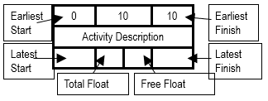
Task | Time [hours] | Dependencies
A: Analysis and Architecture; API definitions | 4
D1: Database for content designed, sample content added | 4 | A
D2: Additional content added to the database | 20 | D1
WA: Admin interface for managing the content | 16 | S-API
WB: Beneficiary interface for browsing the content | 8 | S-API
S-API: Server-side implementation of API for sharing content | 8 | D1
M1: Mobile app – download content | 4 | M-API
M2: Mobile app – play/view content | 4 | M1
M-API: Mobile-side implementation of API for accessing content | 4 | S-API
UX: User Testing | 16 | D2, WA, WB, M2

[3] Dependencies: 3 points total, minus half point for each error (no lower than 0)
[2] Critical Path: Should be A D1 S-API WA UX
2 points for correct identification of critical path, 1 point if A, D1, S-API and UX are correct
Check the following numbers
[3] Earliest Finish: 1pt for UX-EF = 48, 1 pt for D2-EF=28, 1 pt for M2-EF=28
[1] Total float: Latest Start – Earliest Start, 1pt for correct calculation of total float for M-API, even if LS and ES are incorrect
[1] Free float: all zeros
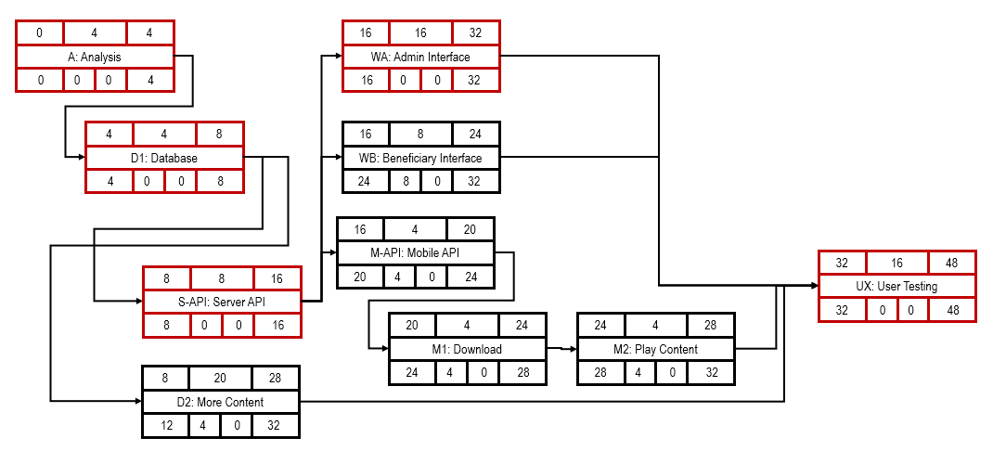

Section 2. ASD2: Software Architecture [15 Marks]

Question 5 [5 Marks]
Give the statement letters of all the statements below that are correct (negative marking applied): [5]
  - Volume testing is when a system is tested with larger and larger amounts of user traffic.
  - Vulnerability scanning is done by automated software that checks software for known vulnerability signatures.
  - A quality gate is a code review that must be passed before code can be incorporated in the master version of a system.
  - Code that obeys the single responsibility principle will have higher cohesion than a god class.
  - One way of achieving lower coupling is to use interfaces instead of subclasses
b, d, e

Question 6 [4 Marks]
Fill in the blanks below: [4]
- MTBF (mean time between failures) is calculated using 3 measures. These 3 are time to ____, time to _____ and time to _______ (give them in any order).
- Software should ideally be easy to use in a variety of different environments, not just in the environment where it was built. This quality is known as software ________
- Code churn is a measure of how often a section of code is _____ (run/changed).

      - diagnose, repair/fix/remedy/equivalentWord, fail/failure (in any order)
      - portability
      - changed
For part 1, give 1 mark if any of the 3 is given, or 2 marks if all 3 are given.

Question 7 [3 Marks]
You have a large generalization hierarchy (many subclasses) of class Item. Explain why it is worthwhile (not overkill) to use the Factory Pattern for creating the different kinds of Item.
Creation code is not duplicated in all classes working with Items. [1 mark]
If a new subclass is added, or an existing one replaced, or the criteria for deciding which subclass applies has changed, of if any of the constructors change their parameters, only the Factory class has to change. [any 2 of these 4]

Question 8 [3 Marks]

Provide the missing statements for the code below that uses the Observer Pattern.
public interface IObserver {
public void update(String message);
}

public interface ISubject {
// not shown here
}
import java.util.ArrayList;
public class TestQ implements ISubject {
protected String name;
protected ArrayList<IObserver> observers = new ArrayList<IObserver>( );
public TestQ (String name) { this.name= name; }
// missing code : see question part 1 below
@Override
public void notify( String s ) {
// missing code : see question part 2 below.
}
}
- At least 2 methods are missing from TestQ if the Observer Pattern is correctly used. Give the method heading for either one of these essential ISubject methods. Choose a method name that makes the purpose of that method clear. [1]

- The notify method should only perform one job/task. Give the code that will implement that one job/task. [2]

1. public void addSubscriber(IObserver observer); // or similar name & that parameter. OR
public void removeSubscriber(IObserver observer); // or similar name & that parameter [1]
2. observers.forEach ( observer -> observer.update( s ) ); // [2] or 1 mark if “update” appears

